Social Stories

There are various Social Stories and Slideshows that can help explain the Coronavirus, the need to wash hands and support children with understanding their emotions. They can be selected on our webpage.
Please read them as a parent or carer first and decide which are most age-appropriate for your family:

- A simple tale of positivity by Joshua Massey

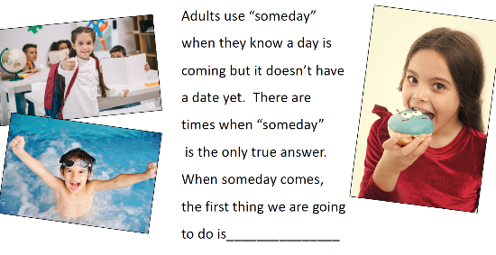
- Someday: A Story of Hope for Children,
a Social Story by Carol Gray

- A Social Story about Hand Washing

- Coronavirus Social Story. EAL – the Coronovirus Social Story can be opened in many different languages. Covibook – an interactive resource designed to support and reassure children aged 7 and under; to help children explain and draw the emotions that they might be experiencing during the pandemic: https://www.mindheart.co/descargables

